District Deputy Grand Master Handbook

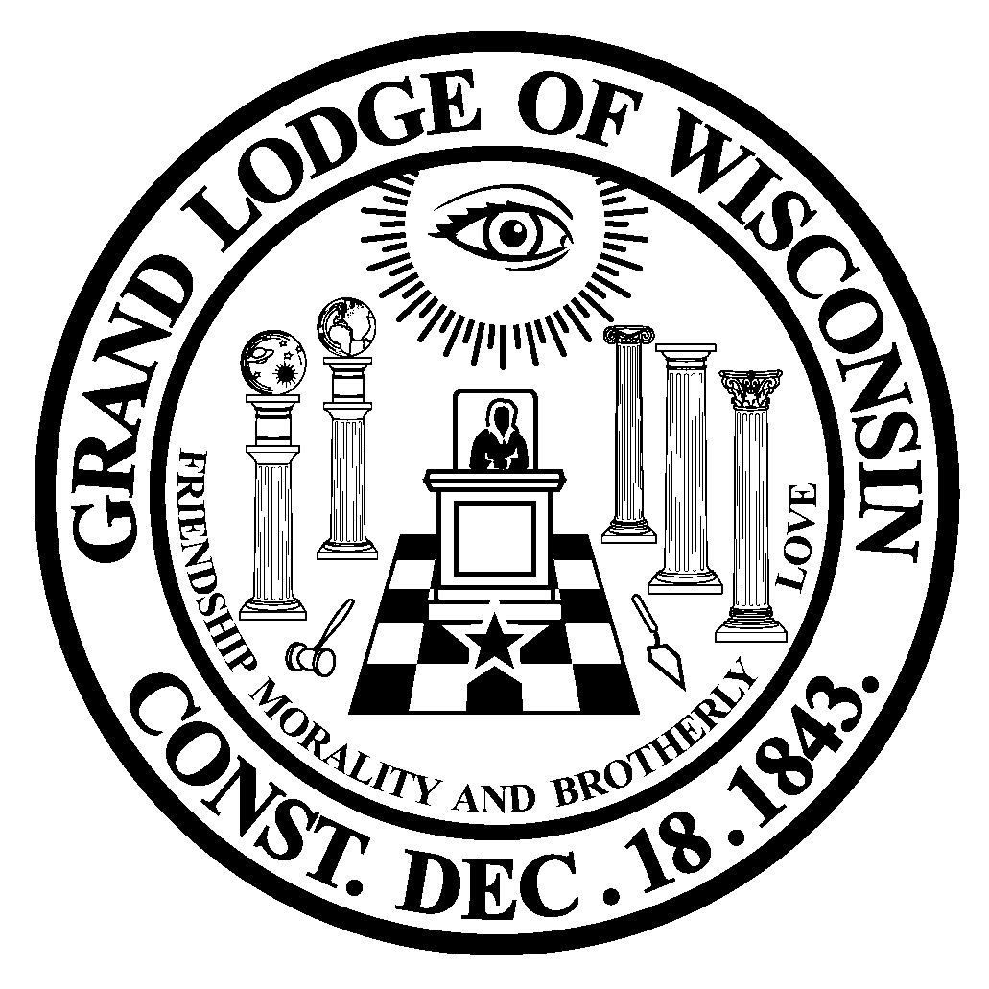

Published By:

Grand Lodge Free & Accepted Masons of Wisconsin

36275 Sunset Drive
Dousman, WI 53118
(262) 965-2200
www.wisc-freemasonry.org

Guidelines:
The District Deputy Grand Master system is defined in Chapter 46 of the Masonic Code of Wisconsin. Upon notification of selection and before accepting appointment, each District Deputy Grand Master (DDGM) should immediately familiarize himself with Chapter 46 of the Code and also Chapter 43, Area Administrator System. Another helpful reference is the Wisconsin Masonic Handbook.

Appointment:

The Grand Master appoints a District Deputy Grand Master for each District. Each is an appointed Grand Lodge Officer and entitled to all the associated privileges. Your first priority is to assist the Grand Master in carrying out his duties and prerogatives. You will be the personal representative of the Grand Master, whenever he, the Deputy Grand
Master or other Senior Grand Lodge Officers are unavailable at local and state functions or as deemed necessary. The appointment is for one year and may be renewed in accordance with section 46.03 of the Wisconsin Masonic Code.

A newly appointed DDGM, either through rental or purchase, will be required to have a black tuxedo. You and your lady are good-will ambassadors for the Grand Lodge and she is encouraged to support you as you fulfill your duties; and it is important to inform her of both your Grand Lodge schedule and your responsibilities. For specific events, she will need appropriate formal wear. She is strongly encouraged to participate in the installation of Grand Lodge Officers, attend Staff Meetings and other events as her schedule allows. As we stress family involvement in our Fraternity, you are welcome to bring minor children to functions such as Grand Lodge Staff Meetings and other public functions. If you will be bringing minor children, please notify the Grand Secretary. All children must be accompanied by their parents while at meals and in the Hospitality Room. It is customary not to have children in the Hospitality Room after 9:00 p.m.

Installation:

Installation is by ceremony at the Annual Communication and it is mandatory that each
Appointee be in attendance, and you will receive your Apron and Collar at that time. Upon notice of appointment, each DDGM designate will be advised of the dates of the Annual Communication, which is set by Code. Each new DDGM designate and his wife will be invited to attend the Annual Communication, other related activities and the Grand Master’s Banquet.

District Deputy Grand Masters’ Organization:

Each DDGM will receive directives either directly from the Grand Master, the Deputy Grand Master who is the liaison with all DDGM’s or from the Chairman of the DDGMs. All questions should be directed to the DDGM Chairman or the Deputy Grand Master, except matters of great importance or of an emergency nature, in which case the Grand Master should be contacted directly.

There are twelve District Deputy Grand Masters who form the District Deputy Grand Master System. They are organized as a unit to function as follows:
- The Grand Master appoints a Chairman of the DDGMs.
- The Chairman may appoint a Secretary to take notes during DDGM breakout sessions.
- Each DDGM is to submit to the Chairman a written report of activities, concerns, and positive actions that can be or are being done by each District. This report will be submitted to the Chairman by each DDGM a minimum of two weeks before each Staff Meeting. An electronic copy of this report is also to be sent to the Grand Master, Deputy Grand Master and Grand Secretary. See Section “District Deputy Grand Master Duties, Principal Duties”, #9 & #10 below for more information.
- In addition to the written Report, each DDGM will deliver a five-minute oral summary of District activities to the Grand Lodge Officers at the Fall, Winter and Spring Staff Meetings.
- The DDGM Chairman will lead discussions at the DDGM breakout sessions according to agenda items determined by the Grand Master, Deputy Grand Master, himself or other Grand Lodge Officers as requested. The Chairman will provide an oral summary of DDGM discussions to the entire Grand Lodge Team. A written report summarizing the DDGM discussion will also be submitted to the Grand Secretary within four days of the conclusion of the Staff Meeting.
- Meetings of the DDGMs are not limited to those held in conjunction with Staff Meetings. A meeting can be called by the Chairman at any time during the year (with permission of the Deputy Grand Master or Grand Master), by the Grand Master or Deputy Grand Master.

Grand Lodge Full Staff Meetings:

The annual organizational Full Staff Meeting is held shortly before of after the Annual Communication, as scheduled by the Grand Master, with all Grand Lodge Officers receiving appropriate notice. Attendance is required unless excused by the Grand Master. This meeting will cover, in depth, the items that the Grand Lodge Officers will be emphasizing during the year.

Subsequent Staff Meetings are generally scheduled in early fall, mid-winter and early spring to review state and local level developments with the Grand Lodge Team. Notification will be sent from the Grand Secretary to all officers informing of event specifics (date, location, agenda, dress code, etc.) and details of hotel and meal accommodations. Please make reservations promptly to enable reservation confirmation with vendors. DDGMs, who register to attend, will be charged for all rooms and meals they do not attend.

District Team Meeting:

This meeting is organized and conducted by the DDGM with the following in attendance:
- Area Administrators
- District Lecturer
- All Grand Lodge Officers residing in the District must be invited
- Ladies may be included if desired

The DDGM will schedule this meeting after each Staff meeting and preferably before District Meetings.

The purpose of the District Team Meeting is to inform all in attendance of the subjects covered at the Staff Meeting and other items, including:
- Grand Lodge projects of emphasis for the year.
- Statewide projects underway.
- Grand Lodge Committee projects.
- Program aids available to the DDGMs, AA’s, Chaplains, Lecturers and Lodges.
- Future dates of the Grand Master and other Grand Lodge Officers.
- Proposed programs and dates as approved by the DDGM for each District Lecturer, Area Administrator and District Chaplain covering all lodges in the District.
- Exchange of ideas by all attendees.

District Meetings:

A District Meeting is to be held a minimum of twice each year in the District and should follow Staff Meetings. The DDGM is responsible for:
- Organizing the meeting
- Making arrangements for a location (usually a Lodge within the District).
- Developing an agenda (set to some extent by the Staff Meeting topics)
- Sending a copy of the agenda to the Deputy Grand Master
- Making arrangements for a lunch or dinner
- Printing of a program
- And informing the Grand Lodge Office, which will send out letters and materials to all Lodges in the District upon request. It is the DDGMs responsibility to actively promote the meeting throughout the District in advance.

The District Meeting is open to all Masons, but attendance is required by the Worshipful
Master and the Wardens of each Lodge unless excused by the DDGM. All Grand Lodge Officers residing in the District should be personally invited. At District Meetings, you are encouraged to include at least one Grand Lodge Officer as a keynote speaker. A list of topics can be found by contacting the Grand Orator. As a courtesy to Grand Lodge Officers, please ensure you request their attendance at least 6 weeks before your event to ensure availability on your preferred date.

To maximize Grand Lodge Officer attendance at District Meetings, no more than two District Meetings may be scheduled on a single day without special permission from the Deputy Grand Master. The DDGM Chairman will be responsible for managing and communicating District Meeting dates with the Deputy Grand Master, District Team and the Grand Lodge Officers. It is required that the DDGM to send out a weekly update of activities within his District to all members of the Grand Lodge Team.

District Deputy Grand Master Duties:
The District Deputy Grand Master is the Administrator of a staff including:
- Area Administrators
- District Lecturer
- District Support Team

District Deputy Grand Masters must ensure Area Administrator perform according to the Code and submit the proper forms and reports to the Grand Lodge office as required.

Principal Duties: (Items 1-4 are mandatory unless excused by the Grand Master.)

- Attend the Annual Communication
- Attend Grand Lodge Officers Summer Full Staff Meeting
- Attend Grand Lodge Officers Staff Meetings
- Attend all functions as requested by the Grand Master
- Visit each lodge in your District at least once each year. Healthy, active lodges should not require more than two official visits per year. Struggling lodges may be visited more often as deemed necessary and with approval from the Deputy Grand Master. If there is a special event scheduled in your District or the Lodge invites you, and this will exceed your two visits, request permission from the DGM and inform the DDGM Chairman.
- Conduct at least two (2) District Meetings each year.
- Conduct a Team Meeting after each Staff Meeting; more may be done at the discretion of the DDGM.
- Submit a proposed budget for your District to the Deputy Grand Master by February 15th (or by requested date) of each year. Include travel expenses for the DDGM, the District Team, meals, telephone, postage and other anticipated expenses.
- Submit an annual ‘State of the Craft’ report for your District to the Grand Master, Deputy Grand Master, Grand Secretary, and District Deputy Grand Master Chairman two weeks in advance of the Winter Staff Meeting of each year. The State of the Craft report is submitted in place of the District Staff Meeting report (see #10 below) at the Winter Staff Meeting. This report is a more detailed and comprehensive report than a standard Staff Meeting report. Content should include major activities; however, emphasis should be on individual, overall Lodge health.
- Submit a District Staff Meeting report for your District to the Grand Master, Deputy Grand Master, Grand Secretary and District Deputy Grand Master Chairman two weeks in advance of the Fall and Spring Staff meetings. The Deputy Grand Master and/or the Grand Master will define the format and expectations of this report (if questions exist, ask!). Note: a regular District report is not required for the Summer Full Staff or the Winter Staff Meeting, (see #9 above).
- Organize District Support Teams for troubled Lodges in your District.
- Assist the District Support Team.
- Keep your District Team and Lodge Officers apprised of all matters regarding Freemasonry.
- Submit monthly expense reports for yourself, and approve and submit expense reports for your Area Administrators.
- Send Area Administrator Visitation Reports to the Grand Secretary for inclusion in the Drop box.
- Any reports made at a Staff Meeting or Annual Communication should be submitted electronically to the Grand Secretary within four days after the conclusion of the Meeting. The report will then be added to the Minutes of the Session.
- See paragraph on ‘District Deputies Organization’ for additional duties.

Other Duties:

- Encourage Lodges in your District to try new and innovative methods to increase membership, finances, fundraising activities, and community involvement opportunities.
- Encourage Lodges to participate in the Lodge Excellence Award (LEA) and State Degree Competition.
- Report to the DDGM Chairman and the Deputy Grand Master any concerns you have relating to your District, District Team or specific Lodges. It is preferable that this be done via email. Together, you can work on solutions to the problems.
- When visiting a Lodge or other Jurisdiction have in your possession, your collar, apron and nametag. It is also recommended that you have a copy or electronic access to the Wisconsin Masonic Code and Handbook in case you are asked a question which may need research.

What do I say if called upon to speak to a group?

- Make sure you are familiar with the positions of the sitting Grand Master and the Grand Lodge Officers. You must be able to relate them to others in a meaningful manner.
- Share and support positions of the Grand Lodge; this demonstrates the unity of the Grand Lodge Officers. Do not inflict personal opinions, pro or con to his positions.
- Always bring greetings and best wishes from the Grand Master to the group.
- Always have something prepared to say; do not ramble, but be on task.
- Remember, when you wear the collar, you are representing the Grand Master and the Grand Lodge. Whatever you say (right or wrong) will be considered gospel.

Supplies:

To properly perform the duties of the office, each DDGM will receive from the Grand Lodge:
- Apron, collar and carrying case of your office
- Name tag
- Wisconsin Masonic Code (Available at the Grand Lodge Website)
- Wisconsin Masonic Handbook (Available at the Grand Lodge Website)
- Wisconsin Multiple Letter Cipher
- Grand Lodge Officers Handbook (Available at the Grand Lodge Website)
- Book of Ceremonies (Available at the Grand Lodge Website)
- Business cards with title
- Directory of Grand Lodge Officers and Committees (Available on MORI)
- Directory of Lodges (Available on MORI)
- Expense Forms (Available at the Grand Lodge Website)

The Grand Lodge Office will furnish on a regular basis:
- Grand Master’s Directives and Edicts
- Minutes of Staff Meetings
- Dates and Locations of Grand Master’s itinerary
- Copies of letters sent to Lodges in general mailings
- Other information regarding your District

Expenses of the District Deputy Grand Master:

The Grand Lodge reimburses the DDGMs for out-of-pocket expenses while performing their assigned duties. The most common expenses are listed below. If you have a question on expenses, please call the Grand Secretary or the DDGM Chairman.
- Mileage: This includes all round trip mileage to functions when in the actual discharge of the duties of a Grand Lodge Officer. Mileage to the Annual Communication is not included; this is covered in a per-diem allowance.
- Meals: This includes the cost of meals for the DDGM and his Lady when in the actual discharge of the duties of a Grand Lodge Officer.
- Lodging: Any lodging necessitated for the DDGM and his Lady when in the actual discharge of the duties of a Grand Lodge Officer. Consult with the Deputy Grand Master in advance for permission.
- Transportation: Any expense incurred from public or private conveyance, other than the DDGM’s own vehicle, that is required while in the actual discharge of the duties of a Grand Lodge Officer.
- Miscellaneous: Any item not listed above that is incurred while in the course or performance of the duties of a Grand Lodge Officer. These should be itemized in the “Other Expense” portion of the expense report. This may include, but is not limited to, such items as long distance telephone calls, postage, and reasonable copying service expense. For extensive typing and copying, call the Grand Lodge Office.
- Submission: Complete and submit expense forms, via email attachment, to the Grand Lodge office (to Grand Lodge Bookkeeper and Grand Secretary) by the 5th of each month. Some of you may want to donate your time and efforts, and we thank you for that. Please fill out the forms and endorse your check back to the Grand Lodge General Fund for expense tracking purposes. Expense reports filed greater than 60 days after an event will not be paid.

Note: Expenses for liquor, wine or beer are not reimbursed by the Grand Lodge.
Traditionally, Grand Lodge Officers and District personnel do not seek reimbursement for recreational activities such as golf, bowling, football or baseball tickets, even if such expenses are related to a Masonic activity.

Expenses of District Personnel:

Area Administrators, District Lecturers and District Support Team expenses are covered by the Grand Lodge, the same as they are for the District Deputy Grand Master, except when overnight lodging is required. District personnel must get approval for overnight lodging from the DDGM. Expense reports for the Area Administrators are against the District budget and must be reviewed by the DDGM before submission. The Grand Lecturer is responsible for approving the expenses of the District Lecturer.

Awards:

Become familiar with, encourage and recognize all award programs sponsored by the Grand Lodge. Consider instituting District recognition programs to encourage brotherly love, inter-Lodge visitation and personal achievements.

Several examples are included below for your consideration:
- Lodge Excellence Award (LEA) – available on the Grand Lodge Website
- Ashlar Award Program – available on the Grand Lodge Website.

District Award Program Examples
- Traveling Apron
- Traveling Lodge
- Lodge with Largest Number of Attendees at a District Meeting
- Master Mason of the District
- Lodge of the District

Training Courses & Seminars:

All District Deputy Grand Masters are encouraged to study and take the Masonic Code Correspondence Course (MCCC) and Masonic Education Correspondence Course (MECC). Both programs are available from the Grand Lodge Website. Participation in Grand Lodge sponsored training sessions is requested, expected and appreciated (example: Secretary’s Training). These courses are also recommended for District Personnel and Lodge Officers.

Area Administrator Visitation Reports:

AA Visitation reports should be filed each time a visitation is made utilizing the approved form located on the Grand Lodge Website. The intent of this form is to track, in real time, Lodge progress. Area Administrators should be encouraged to completely and accurately assess Lodge status and provide meaningful feedback to the DDGM in his report (i.e., “None” is not an acceptable response).

Annual Lodge Inspections:

The DDGM is to carry out annual lodge inspections according to the form located on the Grand Lodge website. It is advised that the DDGM contact the Lodge secretary prior to the planned inspection to enable some activities to be completed and available on the inspection date.
Be fair, but firm on these expectations, and provide accurate feedback to the Lodge on
areas needing improvement. If required, schedule a follow-up meeting with the Lodge to track improvement.

Grand Lodge Officers Handbook & Guide to Protocol:

A full explanation of the guidelines, duties, dress code and protocols can be found on the Grand Lodge of Wisconsin Website.
- Annual Communication: Dress for the Annual Communication is outlined in the Grand Lodge reservation mailer sent in late spring. In general, black tuxedo with black tie, apron, collar and nametag should be available for all events.
- Staff Meetings: Most Staff Meetings are business casual (no jeans), but dress is at the discretion of the Grand Master. See your meeting notice for appropriate attire.
- Lodge Visitations (Tiled): Business suit or business dress casual (depending on what is appropriate for the particular Lodge) unless Lodge officers dress more formally, apron, collar, and name tag.
- Lodge Visitations (Public): Business suit unless Lodge officers dress more formally, collar, and name tag.
- Masonic Memorial Services: Business suit, white aprons, white gloves (if worn by Lodge members).
- Visitations to Other Masonic-Related Bodies (at Lodge): Business suit, collar only, and name tag.
- Visitations to Other Masonic-Related Bodies (other than Lodge): Dress according to activity and location, collar if appropriate, and name tag.
- Special Meetings (District, Schools of Instruction, Proficiency School): Business suit or sport coat with tie, apron and collar (if tiled, otherwise, just collar), and name tag.
- Special Occasions (Cornerstone, Dedication, and Honor Ceremonies): As directed by the Grand Master. Always bring your apron, collar, and name tag.

Outgoing District Deputy Grand Master:

The outgoing District Deputy Grand Master will furnish to the new District Deputy Grand Master:
- Copy of the most recent Annual Report for the District
- Copy of budget for the District
- Names and addresses of District Team members
- All Grand Lodge items in his possession.

Assistance:

The Grand Secretary and the Grand Lodge Office personnel are always available to answer any questions, and if they cannot do so they will advise you whom to contact. They are also always ready to give assistance in typing work, making copies and mailings if enough time is allowed.

Remember, for any problems in your District your first contact should be the DDGM Chairman, then the Deputy Grand Master. If the problem is of great importance, or needs immediate attention and you cannot contact the Chairman or DGM, call the Grand Master.

