Passport to Ritual Proficiency

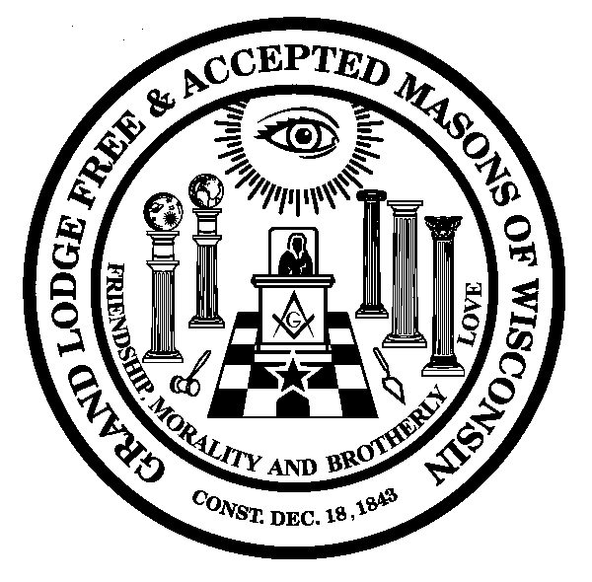

This booklet is your passport, or checklist, to achieving a Ritualist and Proficiency card. All the tasks needed to qualify for a Ritualist card are listed under each degree heading. When you feel you are proficient in a particular task, or tasks, contact your District Lecturer to arrange for your examination. Once you have been certified in all required degree tasks, your District Lecturer will submit a Ritual Award Request form to the Grand Lecturer. The Grand Lecturer will review, approve and forward to Grand Lodge. Your Ritualist card will be sent to your District Lecturer for distribution.
Ritualists or Proficiency card holders must be re-certified annually. To re-certify, you need to attend and participate in your District Schools of Instruction, be active in degree work and be recognized as a mentor and instructor. Your District Lecturer will certify that you have met these criteria.

Name:
Lodge:
District:
Entered Apprentice Degree

Required Tasks:
Task | Examined By |  | Date
Opening
Degree Conferral
Closing the Lodge
Second Section Lecture

Optional Tasks (Not Required):
Third Section Lecture
Charge

Date Awarded:

Fellowcraft Degree

Required Tasks:
Task | Examined By | Date
Opening
Calling Down to EA
Resuming Labor in FC
Degree Conferral
Closing
Second Section Lecture

Optional Tasks (Not Required):
Letter G- Lecture
Charge

Date Awarded:

Master Mason Degree

Required Tasks:
Task | Examined By | Date
Opening in MM
Calling Down to FC
Resuming Labor in MM
Degree Conferral
Closing the Lodge
Second Section
Historical Lecture

Optional Tasks (Not Required):
Third Section Lecture
Charge
Apron Address
Bible Presentation

Date Awarded:
Proficiency Man

Required Tasks:
Task | Examined By | Date
Reception of Grand Lodge Officers

Ritualist Card History | Date Awarded
EA Ritualist
FC Ritualist
MM Ritualist

Date Awarded:

