28 June 2016

Mrs. Grace Nestler-Bramm
2454 N. Lake Drive
Milwaukee, WI 53211

Dear Mrs. Nestler-Bramm:

Your husband has received his First Degree in the Masonic Fraternity. He is now an Entered Apprentice and you are now a Mason’s Lady. While you personally have not joined our organization, there are certain things that may be helpful for your to know in the future. At the same time, there are matters of general interest about your Mason and his new Fraternity that we think you would like to know.

WHEN AND WHERE DID IT BEGIN?

The Fraternity of Free and Accepted Masons (F.&A.M.) is the oldest, largest and most widely known fraternal organization in the world. It has its roots in antiquity and is directly descended from the association of “operative masons”, the cathedral builders of the Middle Ages, who traveled through Europe employing the skills of their craft. The organization, as we know it today, began in 1717 in England when cathedral building was on the decline and the “operative masons”, or “free masons” as they were known, started to
accept members who were not members of the mason’s craft, calling them “speculative masons” or “accepted masons”.

Freemasonry was brought to the United States by our early settlers. Today, there are 178 Masonic Lodges in Wisconsin with membership totaling nearly 11,000. Through out the world, there are approximately five million Masons, with nearly three million of them in the United States.

WHAT IS THE PURPOSE OF FREEMASONRY?

The basic purpose is to make “better men out of good men”; better fathers, better husbands, better brothers, and sons. We try to place emphasis on the individual man by strengthening his character, improving his moral and spiritual outlook and broadening his mental horizons. We try to build a better world...by building better men to work in their own communities.

Membership is limited to adult males who can meet recognized qualifications and standards of character and reputation.
IS FREEMASONRY A SECRET ORGANIZATION OR A RELIGION?

The answer is NO. A secret organization is one which conceals its membership, which has secret meeting places and which conceals from the public, its organization or its principles. This description does not fit the Masonic Fraternity at all. Our secrets are very few in number and deal 9tily with methods of personal recognition, some details of our degrees and privacy of each member’s ballot.

Freemasonry is not a religion, although it is religious in character. Every applicant for Masonry must express a belief and a trust in God. Masonry does not take the place of religion. It stresses the personal commitment and involvement of each member in the religious community of his own choice.

WHAT ARE THE DEGREES?

Lessons in Masonry are taught in three separate stages in our Masonic Lodges. The degrees, in order are Entered Apprentice (first degree), Fellowcraft (second degree), and Master Mason (third degree). Each blends Masonic moral philosophy in a unique lesson which is intended to have a serious impact and influence on the man who receives the degree.

WHAT ARE MASONIC APRONS?

The symbolic apron was worn by operative masons to protect themselves from rough stones and tools. Presently, it is a badge of fraternal distinction. It represents the white lambskin, a symbol of innocence. Some decorations may appear on Masonic Aprons and often designate an officer or special recognition. All are, however, a proud display of membership in this world-wide Fraternity.

WHAT DO MASONIC SYMBOLS MEAN?

The most widely recognized symbol of the Fraternity is the Square and compasses with the letter “G” in the center. Members wear it to remind themselves of their obligation to the lessons learned in their Lodges, and to identify their membership to other Masons and all people. Masonic symbols have wide meanings, some directly relate to the tools used by actual operative masons and some, represent the need for order and direction in life. The letter “G” represents God, the Supreme Architect of the Universe.

WHEN ARE MEETINGS HELD?

Lodges meet in regular monthly sessions called “stated meetings” and on such other days as are necessary to conduct its business and ritualistic work. While every Masons’s attendance is earnestly solicited, yet it is not intended that a Lodge should interfere with his work or with his obligations to his family or his God.

Your husband has invested time and money in joining our Fraternity. He can best receive all that he should by frequently participating in its deliberations and events. We hope that you will approve and encourage him to attend regularly, and we hope also, that you, too, will join us whenever possible for the guest activities held by the Lodge.

SHOULD I CONTACT ANYONE WHEN MY HUSBAND IS ILL OR HOSPITALIZED?

In the event any member of our Lodge becomes ill, we want to know. You may call the Master or Secretary of this Lodge. Your husband has joined an organization that wants to assist him and you when in need, and we need your help to do it.

WHAT CAN YOUR INVOLVEMENT BE?

Countless opportunities abound through active participation and membership in any of the numerous Masonic-related ladies organizations. You are encouraged to share in many activities of the Lodge. Non-Masonic friends and families may also take part in many Masonically supported programs.

We hope you will be proud that your husband has chosen to become a member of the world’s oldest and best fraternity. We welcome you as a “Mason’s Lady”.

Until then, I remain,

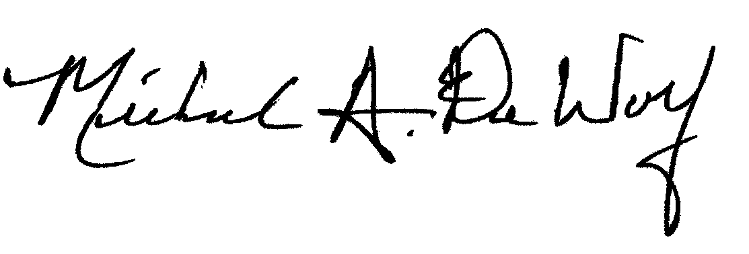
Sincerely and Fraternally,

Michael A. DeWolf, PGM
Secretary/Treasurer
Wauwatosa Lodge No. 267 F&AM

