March 24, 2016

Brother Robert ‘Beau’ Blask
1324 Hillwood Blvd., Apt. F
Pewaukee, WI 53072-6519

Dear Brother Blask:

Now that you have been passed to the degree of Fellowcraft, I again take pleasure in congratulating you on your advancement in Masonry. Only one more step remains before you earn full membership in Wauwatosa Lodge #267.

As you know, your Coach is Brother Joshua Riewe, 1359 S. 96th St., West Allis, WI 53214; 262.424. Get in touch with him promptly and work out your coaching schedule with your Second Degree Coach, thus relieving him of the responsibility of seeking you out in connection with this necessary work. Your FC Examination is scheduled for April 11, 2016 at 7:00pm.

With respect to attendance, you are now invited to be present at the Lodge on all First Degree and Second Degree nights. Additionally, you are invited to attend the second half of our Stated Meetings. I hope that you will take advantage of all such occasions to become better acquainted with the members of your Lodge.

Remember my suggestions about inviting relatives, business associates or other friends whom you understand to be Master Masons, particularly on the evening of your Third Degree. It will mean a great deal to those friends of yours to be present and in later’ years, as you look back, it will mean much to you.

Finally, let me point out that the First and Second Degrees, impressive as they are, simply help to prepare you for the big step -the ceremony when you are raised to the Sublime Degree of Master Mason. I join you in anticipating that eventful occasion which is scheduled for May 9, 2016 at 7:00pm.

Until then, I remain,

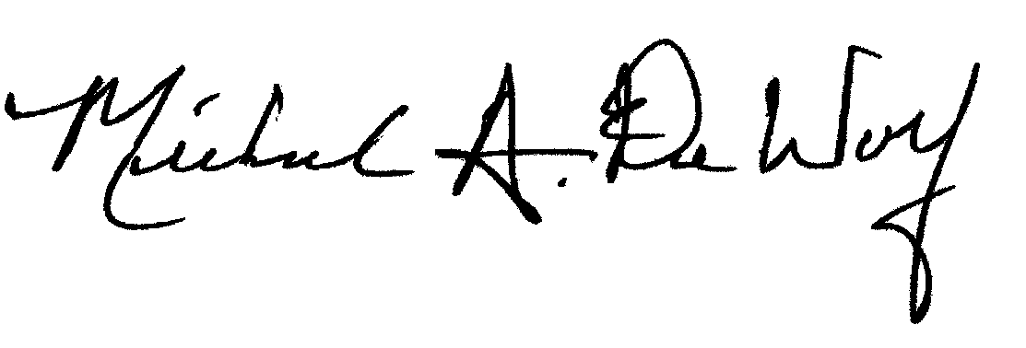
Sincerely and Fraternally,

Michael A. DeWolf, PGM
Secretary/Treasurer
Wauwatosa Lodge No. 267 F&AM

