9 January 2017

Mr. Shane T. Taylor
436 S. 73rd Street
Milwaukee, WI 53214

Dear Mr. Taylor:

It is my pleasure to inform you that at the Stated Communication of Wauwatosa Lodge No. 267 F.&A.M. held on the 9th day of January 2017. You were elected to receive the Degrees of Freemasonry.

The Worshipful Master requests, therefore, that you present yourself at the Lodge located at 7515 W. National Avenue, West Allis, Wisconsin on February 27th, 2017, for your Initiation. You are requested to be at the lodge prior to 7:00 pm. Dress for the evening is coat & tie or shirt & tie, depending on the temperature.

The fees for the Degrees in Wauwatosa Lodge are $175, plus the Annual Dues of $94. The Annual dues will be prorated depending on when you receive your 3rd Degree. Please bring cash or a check payable to Wauwatosa Lodge #297 for $175 with you on Monday the 12th.

If for any reason you are unable to appear at the above time, please notify me in advance of the date. I may be reached at the following: 262-965-2200 - Office, 715-574-3151 - Mobile, or by email at michael.dewolf33@icloud.com.

Enclosed you will find a book titled Seeking Light. This is the first in a series of candidate preparation material and is designed to help you understand the structure and purpose of the fraternity. Please review this prior to receiving your 1st degree.

It is my please to welcome you to the worlds largest fraternity.

With best wishes, I am,

Sincerely and Fraternally,
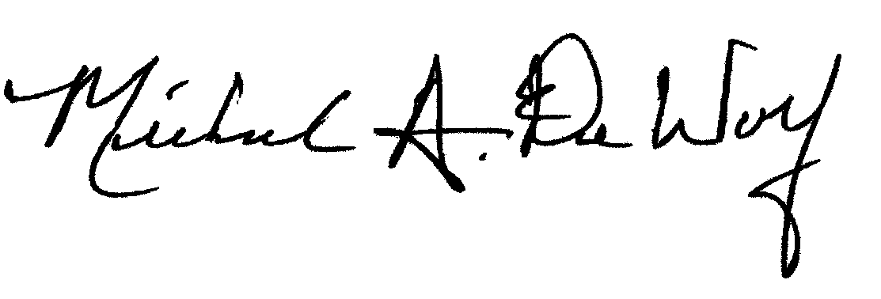

Michael A. DeWolf, PGM
Secretary/Treasurer
Wauwatosa Lodge No. 267 F&AM

