27 October 2016

Brother Charles Abiff
2525 S. Lake Drive
Milwaukee, WI 53207

Dear Brother Abiff:

Now that you have been initiated an Entered Apprentice Mason, I congratulate you on taking this first step toward full membership in Wauwatosa Lodge. Since this is a totally new experience for you, a few points are listed below which may be of interest and of help.

1. You have participated in a time-honored ceremony, the Masonic ritual of the First Degree. I am sure you understand the complete and binding requirement of total secrecy with regard to our ritual. While we have secret signs, words and tokens, which we use as means of recognition, vie are not a secret society. The location of our lodges can be found in the local phone book. Similarly, many of our members openly wear Masonic symbols signifying that they are Masons and belong to a Masonic Lodge. Nor is the philosophy that we stand for secret - Brotherly Love, Relief and Truth; and the brotherhood of man.

2. Before you can be passed to the degree of Fellowcraft, you now must commit to memory a small portion of the First Degree and the lessons contained. Do not delay in getting stated with this work. It is not too difficult a task, but the longer you wait, the harder it is to learn. Moreover, the degree schedule of the Lodge assumes that you will proceed promptly to the next step.

3. Remember that Masonic teachings have been passed down through the ages by word of mouth with the help of a cipher. Your Mentor is a dedicated Mason who has volunteered to impart these learned phrases to you as you work toward advancement. He is responsible to assist you in becoming proficient in the candidate’s Posting of the Entered Apprentice Degree and to prepare you for examination before proceeding to the next step. All the material necessary to complete your posting for this degree is found in the red Wisconsin Program Book ‘Light in Masonry’ which was presented to you on the evening of the your Entered Apprentice Degree.

4. Your Mentors are Brothers Richard Smith, 262-391-2948 and Scott Johnson, PM 414-609-2974. They will help guide you through the posting process. Please feel free to call them anytime you have questions or need help with your lesson.

5. Your rights and privileges in the Lodge are limited until you become a Master Mason. As an Entered Apprentice Mason you may only attend the second half of our Stated Meetings on the second Monday of each month. Stated Meetings are opened in the Third or Master Mason’s degree. You are most welcome at all functions of the Lodge not restricted to Master Masons. You may not visit another Masonic Lodge, except to observe an Entered Apprentice Degree. You are expected to be present at each Lodge meeting when a First Degree is scheduled, not when Second or Third Degrees are scheduled. Our Trestleboard which will be mailed to you, will keep you updated on our events.

6. Please remember to invite friends and relatives whom you understand are Master Masons to attend Wauwatosa Lodge, particularly on the nights when you are to receive a degree. We heartily welcome visitors, and any Mason considers it a compliment to be invited when someone he knows is to receive a degree.

7. Finally, understand that all the rules and regulations, such as those I refer to, have been established for a purpose and that all Masons who have preceded you have been governed by the same procedures. Do not hesitate to ask questions as they may arise - of your Mentor, or any officer or any member of the Lodge - but, above all, remember that I am as close to you as the nearest telephone and always available for consultation and advice.

8. Very shortly you will be invited to attend an informal review and discussion of the degree you have just taken. Please feel free to raise at that meeting any questions you have about Masonry or about the Entered Apprentice Degree.

Good luck as you go forward in your Masonic work. I look forward to the occasion when I may take your hand as a Master Mason and welcome you into full membership in Wauwatosa Lodge.

Until then, I remain,

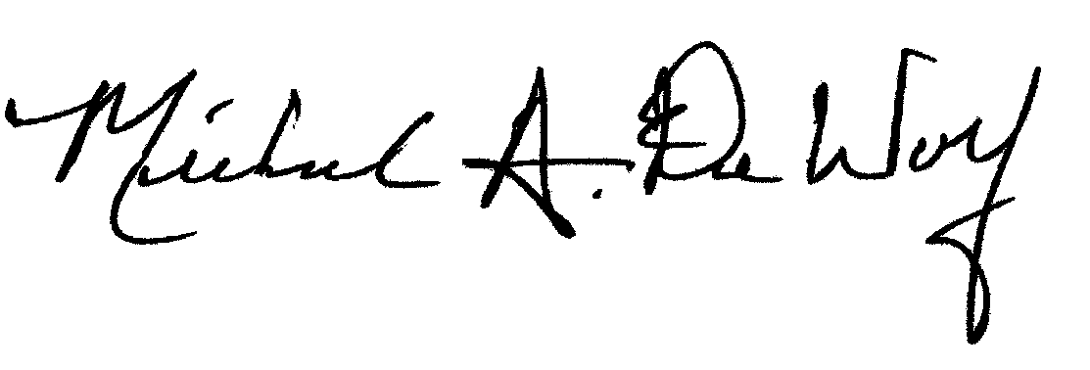
Sincerely and Fraternally,

Michael A. DeWolf, PGM
Secretary/Treasurer
Wauwatosa Lodge No. 267 F&AM

