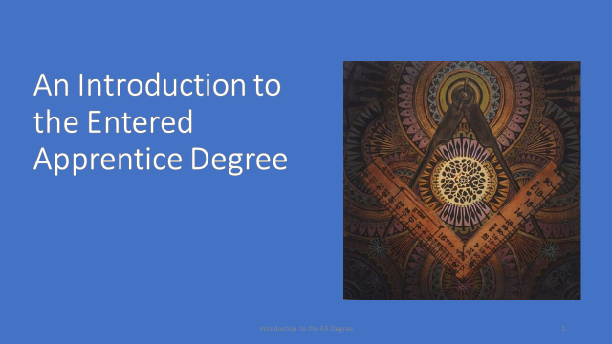

For the next few minutes, we are going to review some points and symbolism of the Entered Apprentice degree of Freemasonry.

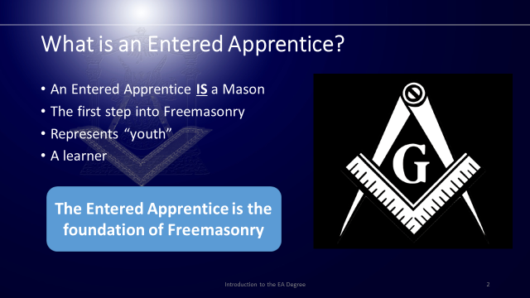

What is an Entered Apprentice?
(CLICK FOR BULLET)
An Entered Apprentice is a Mason in the sense that a building under construction is called a building. An Entered Apprentice does have privileges, duties, and limitations. For example, an Entered Apprentice has the right to be instructed on all matters pertaining to the degree and a right to apply for advancement through the in-Lodge examination. You have the duty to be faithful to your obligation and his Brothers. It is also your duty to learn the required portions of the degree.
(CLICK FOR BULLET)
Some say the Entered Apprentice degree is an introduction to Freemasonry, but I prefer to think of it as a first step into Freemasonry, the foundation.
(CLICK FOR BULLET)
The Entered Apprentice represents ‘youth’ and you are expected to “occupy his mind with the attainment of useful knowledge.”
(CLICK FOR BULLET)
From the Entered Apprentice charge: “At your leisure hours, that you may improve in Masonic knowledge, you are to converse with well-informed brethren who will always be as ready to give as you will be ready to receive instruction.”
(CLICK FOR TOMBSTONE)
The Entered Apprentice is the foundation on which the lessons of Freemasonry are built upon.

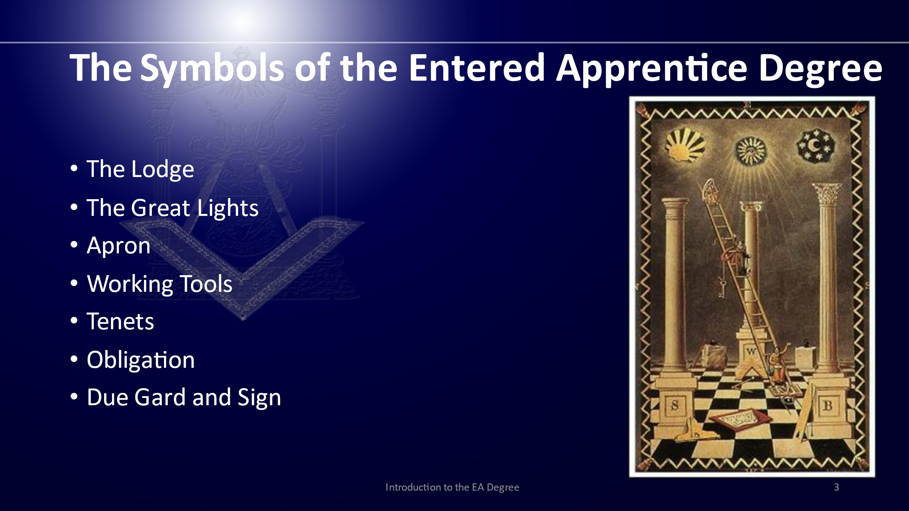
(REVIEW THE BULLET POINTS)
- There are many symbols within the Entered Apprentice degree, we are going to review just a few of them today.

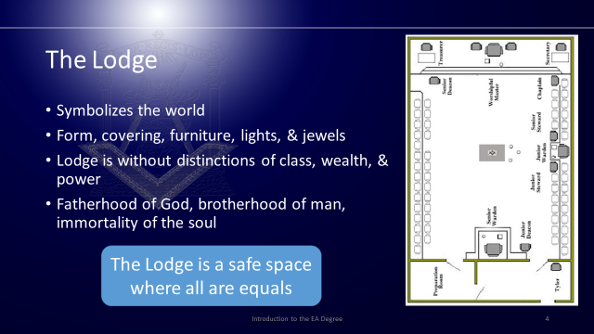
In Freemasonry, “Lodge” has three meanings: the place where Masons meet, the assembly of the brethren duly congregated for Masonic labor, and a piece of furniture.
(CLICK FOR FIRST BULLET)
The lodge is a symbol of the world and its shape, the "oblong square" was anciently thought to the be the shape of the world.
(CLICK FOR NEXT BULLET)
The form, covering, furniture, lights, and jewels are explained in the Lodge of the Entered Apprentice degree. You will learn more about the Lodge as a symbol as you proceed through the degrees.
(CLICK FOR NEXT BULLET)
In the world of the Lodge, there is no distinctions of class, wealth, and power. In the Lodge, all are equal, or on the level, and peace and harmony prevail.
(CLICK FOR NEXT BULLET)
In the Lodge men are united in the common bond of three fundamental beliefs: The Fatherhood of God, the brotherhood of man and the immortality of the soul, and all the sweet associations which come from them.
(CLICK FOR TOMBSTONE)
The Lodge is a safe space, a space away from the troubles of the world where we, as Masons, can focus on those things that makes Masonry so special.

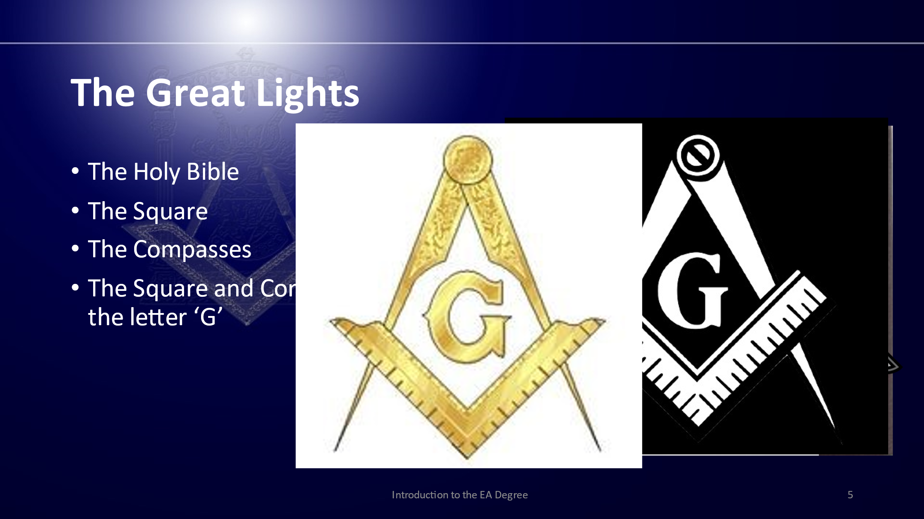
The Entered Apprentice is introduced to the Three Great Lights of Freemasonry, the Holy Bible, square and compasses.
(CLICK FOR BULLET)
The Holy Bible, sometimes referred to as the Holy Writings, is the "The Great Light in Masonry“ and is opened on the altar. Here the Bible is a symbol of all holy books of all faiths. It is how Masonry establishes the simplest and most profound truth: that there is a way for all men to travel together with nothing to divide them.
(CLICK FOR BULLET)
The Square reminds us to square our actions. It represents morality, the ethical and right conduct that must form the basis of our every action as the foundation of society. The square is not for any one Lodge, any one nation, any one religion – it is for all Masons, everywhere. It is universal and transcends all languages.
(CLICK FOR BULLET)
The compass establishes the limits of our conduct by measuring out ability to wisely conduct actions within certain boundaries. Like the square they are recognized by all Masons wheresoever dispersed.
(CLICK FOR BULLET)
The square and compasses pictured together with the letter G in the center representing the Holy Writings are the emblems of Freemasonry. This emblem represents the fraternity. It serves to remind every Mason of our obligation to obey the moral law.
(CLICK FOR TOMBSTONE)
Much has been said and written about the emblem of the fraternity, more than can be comfortable said here. Together they symbolize all the things they represent individually and when used together they represent the greatest fraternity the world has ever known.

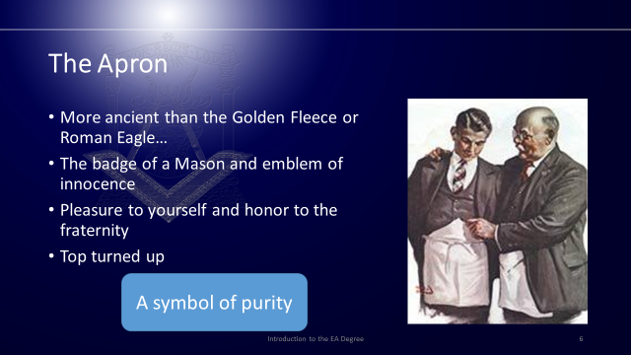
In the Entered Apprentice degree, the new initiate is presented with a white ‘lambskin’ or white ‘leathern apron’ and is provided with a detailed explanation.
(CLICK FOR BULLET)
More ancient than the Golden Fleece or Roman Eagle, more honorable than the Star and Garter, and so on. With this description, the ritual impresses the importance of this symbol upon the candidate. It being more honored and more a prized possession than these other orders.
(CLICK FOR BULLET)
It being a visual link to our ancestors of the ancient stone mason’s guilds who wore aprons to protect their clothing, and that its color is associated with purity in nearly every culture and society, its link to Freemasonry is undeniable. It simultaneously represents a Mason’s labor and strides to live a moral life.
(CLICK FOR BULLET)
You are instructed to wear it with equal pleasure to yourself and honor to the fraternity to impress upon your mind and heart that you should never allow it to be stained or sullied through your thoughts and actions.
(CLICK FOR BULLET)
As an Entered Apprentice, you wear it with the top turned up to identify you as an Entered Apprentice, or bearer of burdens.
(CLICK FOR TOMBSTONE)
As the apron identifies us a Masons, we wear it to signify our intentions to lead a moral life that is the distinguishing characteristic of a Mason.

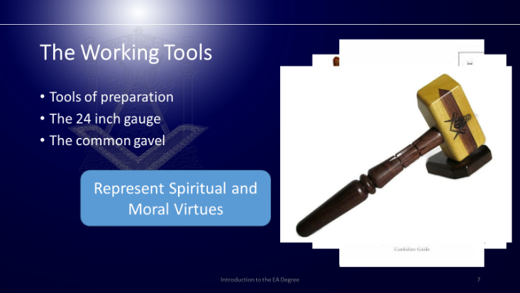
The working tools of an entered apprentice are the 24-inch gauge and common gavel.
(CLICK FOR BULLET)
The ashlar, or stone to be used in a building, represents our moral character and requires constant work and manipulation by way of the working tools. The working tools presented to the Entered Apprentice are tools of preparation. They are used to prepare the rough ashlar of our character by removing the visible imperfections.
(CLICK FOR BULLET)
The 24-inch gauge teaches us to monitor and divide our time so that we may spend part of our day in prayer to the Supreme Architect of the Universe, part in labor and refreshment and part serving a friend or Brother in time of need. It reminds us that we are mortal and that we should strive to live a productive life with the time we have.
(CLICK FOR BULLET)
The common gavel represents the force of conscience, which, of course, is the voice of our own soul. It is this inner voice that is ever ready to warn us when we are about to morally err. By removing the vices and other unnecessary portions of our character, our conscience will be easier to hear and therefore it will guide us through the moral path. If we do not allow it to guide us, failure becomes a habit, and its voice will eventually become so weak that it is barely audible.
(CLICK FOR TOMBSTONE)
Together, the working tools represent the spiritual and moral virtues by which a man may adjust himself to the requirements of human society.

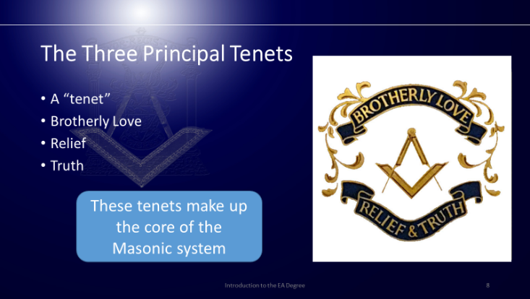
The tenets of our profession are brotherly love, relief and truth.
(CLICK FOR BULLET)
A “tenet” is a teaching so obviously true, so universally accepted, that we believe it without question. For example, good health is better than sickness, a truthful man is more dependable than a liar, education is preferred to ignorance, are all tenets.
(CLICK FOR BULLET)
Brotherly Love means that a man places on another man the highest possible valuation as a friend, a companion, and an associate. To spend time in his company and to work at his side is an enjoyable privilege. As Freemasons, we do not ask to profit from this relationship, out relationships with our Masonic Brother is its own justification and its own reward.
(CLICK FOR BULLET)
Masonic Relief is a form of charity. There is one aspect of Masonic relief that is different. No matter how careful and industrious a Mason may be, through sudden misfortune or other conditions over which he has no control, he may be in temporary need of a helping hand. While this may be thought of a charity, it is one of the natural and inevitable acts of Brotherhood. The purpose of the ‘rite of destitution’, when you were asked for “a dime, or a smaller coin” in your Entered Apprentice degree, emphasizes the tenet of Masonic Relief.
(CLICK FOR BULLET)
Truth, as a Masonic tenet, is much more than the search for truths in the intellectual sense, although that is part of its meaning. Masons must be truthful in character and habit, dependable, honorable, and honest. In short, Masons must be men on whom others can rely.
(CLICK FOR TOMBSTONE)
Freemasonry does not tell us that Brotherly Love, Relief and Truth ought to be true, nor that it would be better for us if they were true, Freemasonry tells us that they ARE true. The problem is not whether we believe them. The challenge is what we are to do with them.

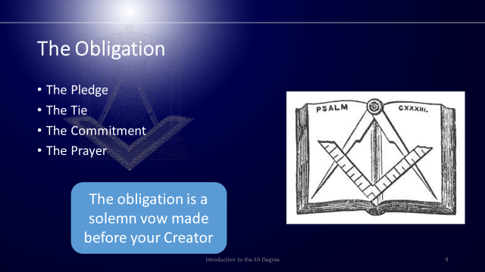
The obligation is a tie, a contract, a pledge, a vow, and a duty that is owed. We assume the Masonic obligations voluntarily and it is important that we understand it fully. In can be broken into four parts.
(CLICK FOR BULLET)
The first section can be called the Pledge. Here you are promising to keep the secret parts of the Entered Apprentice degree from another you have not verified is a true Brother Mason.
(CLICK FOR BULLET)
In the second section, or tie, of the obligation you bind yourself to the fraternity promising what you will or will not do as an Entered Apprentice. Your promise or bond in this case is not to make any of the secrets legible in writing.
(CLICK FOR BULLET)
Here you are committing to keep all the promises made. Understanding the mental pain, you might have in addition to the contempt and distrust of your Brother Masons by not keeping those promises which is the purpose of the symbolic penalty.
(CLICK FOR BULLET)
In the prayer, you are asking for your Creators for help in keeping these promises.
(CLICK FOR TOMBSTONE)
The obligation is a solemn vow made before your creator with his help in keeping the same. Your commitment to this obligation does not end when the following degree is conferred upon you. A Mason can be depended upon to fulfill his obligations to the best of his ability.

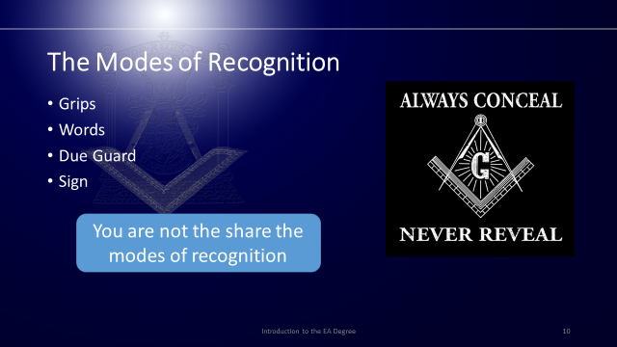
The modes of recognition are how one Mason may recognize another among strangers. Through them we are able to prove others or ourselves to be regular Masons in order to enter into fraternal fellowship and to receive the rights and benefits of the degree. These consist of the word and grip of an Entered Apprentice as well as the due guard and sign. All of which were given to you at the altar immediately after taking the obligation.
(CLICK FOR BULLET)
The grip is the Masonic handshake of this degree and its primary purpose is to be able to greet another Brother in a warm, friendly, and Brotherly manner that he will recognize by feel which enables it to be used to equal effect in the dark as well as the light.
(CLICK FOR BULLET)
The word of the Entered Apprentice degree was also given to you at the altar. It is the name of the grip and both were given at the same time. When asked to give the word of an Entered Apprentice, you should always give it in the same manner you received it.
(CLICK FOR BULLET)
The due guard alludes to the position your hands were placed when taking the obligation and reminds us of those things to which we committed to through it.
(CLICK FOR BULLET)
The sign alludes to the symbolic penalty and likewise reminds us of our commitment to keep the obligation and the contempt and distrust of your Brother Masons by failing to do so.

The due guard and sign together form the salute of an Entered Apprentice. Together they symbolize your recognition and respect for the authority of the principal officers when within the Masonic Lodge. It is also a symbol of a Mason’s respect for and obedience to all just and duly constituted authorities.
(CLICK FOR TOMBSTONE)
You promised in your obligation never to share these with anyone you cannot prove to your satisfaction is a Mason and as entitled to them as you are yourself.

You should practice these with your mentor or another well-known Brother so that they become comfortable and to some extent, are second nature.

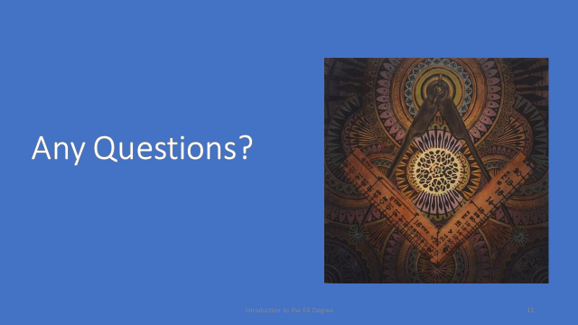
What we went through today are some of the symbols of the entered apprentice degree.

A symbol is something that represents or stands for something else, usually a material object representing an abstract idea.

There are many, many other symbols within the Entered Apprentice degree. All these symbols are there for you, the candid and industrious enquirer, to discover for yourself!

