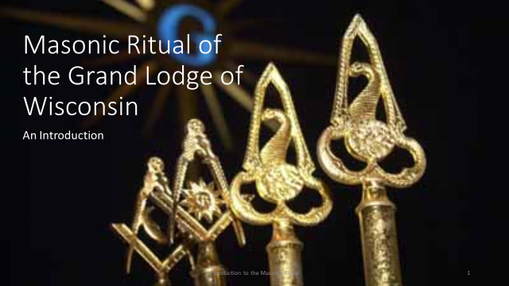
The purpose of this presentation is to give you a little background into what the Masonic Ritual is.

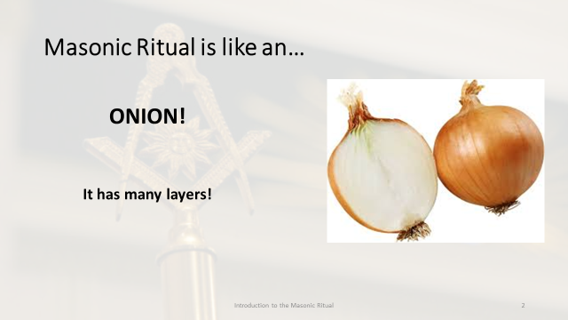
Masonic ritual is like an…
CLICK TO REVEAL THE IMAGE
Onion
CLICK TO REVEAL THE TEXT
It has many layers!
In today’s presentation we are just going to peel the outer skin off that onion. But be assured there is much more to discover.

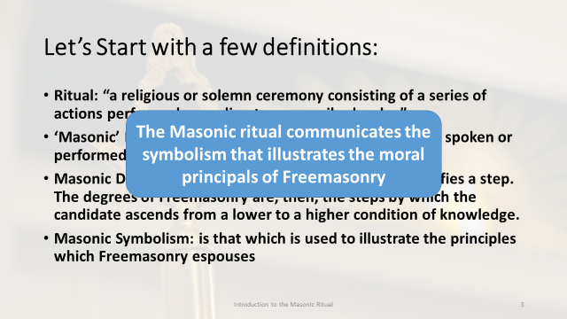
Before I get into any of the details on Masonic ritual, I think it is important to start with a few definitions.
(CLICK FOR BULLET)
Ritual: “a religious or solemn ceremony consisting of a series of actions performed according to a prescribed order.”
(CLICK FOR BULLET)
‘Masonic’ Ritual: the scripted words and actions that are spoken or performed during the degree work in a Masonic Lodge.
(CLICK FOR BULLET)
Masonic Degrees: The word degree, in this context, signifies a step. The degrees of Freemasonry are, then, the steps by which the candidate ascends from a lower to a higher condition of knowledge.
(CLICK FOR BULLET)
Masonic Symbolism: is that which is used to illustrate the principles which Freemasonry espouses.
CONCLUDE
From these definitions, we can conclude that Masonic ritual is the spoken word and actions used by the Fraternity to communicate the symbolism that illustrates the moral principles of Freemasonry.

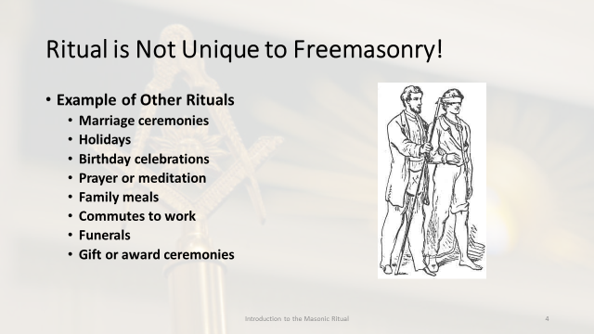
The term ‘ritual’ was scary to me when I first joined the Fraternity as it had an almost sinister connotation.
As I learned more, I realized that rituals all around us!

Here are some examples of common rituals that we see in our day-to-day life.

Every culture has sought methods to pass social mores, taboos and norms down to new (younger) members and every society from the South Pacific, through China, Africa and Europe have used ritual for this purpose. Ritual use is both global and universal, the difference is only in what is being taught and how.

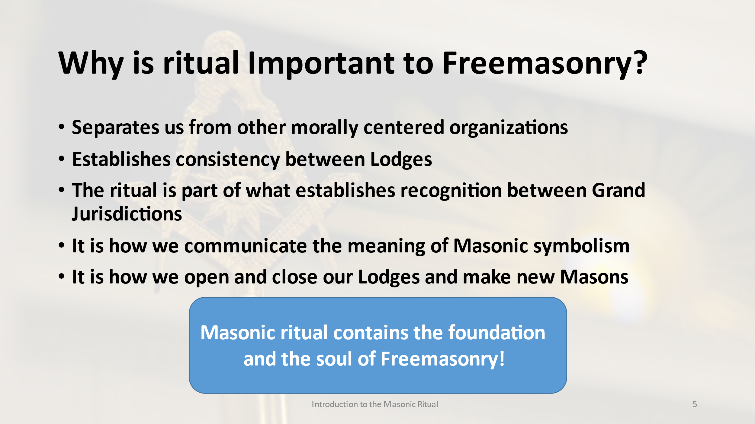
Why is ritual important to Freemasonry?
(CLICK FOR BULLET)
The lessons taught in our ritual and how we teach them differs from other social or morally centered organizations.
(CLICK FOR BULLET)
The ritual ensures the principals of Freemasonry are communicated consistently from Lodge to Lodge.
(CLICK FOR BULLET)
There are many requirements to establish recognition between Grand Jurisdictions, one of them is the conferral of the Entered Apprentice, Fellowcraft and Master Mason degrees.
(CLICK FOR BULLET)
The ritual is how we communicate the meaning of the Masonic symbolism.
(CLICK FOR BULLET)
The ritual contains the words and actions necessary to open and close our Lodges and how we make new Masons.
ASK CLASS FOR OTHER REASONS
Note that there are variations between jurisdictions
CLICK TO REVEAL THE TOMBSTONE AND REVIEW
The Masonic ritual contains the foundation and the soul of Freemasonry! Without the ritual, Freemasonry would be something different.

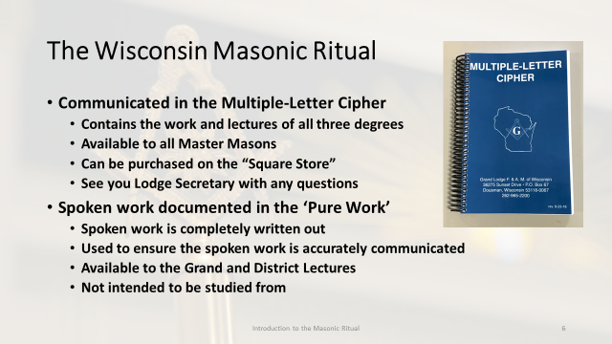
Every Grand Jurisdiction maintains its ritual a little differently. In Wisconsin the ritual is maintained in two pieces: the multiple-letter cipher and the pure work.
(CLICK FOR BULLET)
The entire ritual is contained within the Multiple-Letter Cipher
(CLICK FOR BULLET)
The cipher contains the spoken parts and movements for all three degrees.
(CLICK FOR BULLET)
The cipher is only available to Master Masons.
(CLICK FOR BULLET)
The cipher can be purchased by a Wisconsin Master Mason through the Grand Lodge of Wisconsin “Square Store”
(CLICK FOR BULLET)
Your Lodge Secretary is able to help or answer any questions.
(CLICK FOR BULLET)
The spoken portion of the work is printed in the ‘Pure Work’
(CLICK FOR BULLET)
The spoken work is completely written out, not in cipher
(CLICK FOR BULLET)
Its purpose is to ensure the spoken portion of the work is accurately communicated
(CLICK FOR BULLET)
It is available to the Grand and District Lectures and they will allow you to review it on request or at a school of instruction or district meeting
(CLICK FOR BULLET)
It is a resource. It is not intended to be studied from.

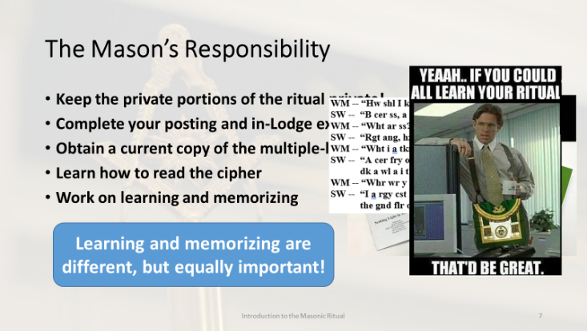
Every Mason has several responsibilities related to the ritual. Here are some of them.
(CLICK FOR BULLET & PICTURE)
There is a long-standing debate within Freemasonry: are we a secret society or a society with secrets. Without delving into that debate let us just say there are aspects of the ritual in particular that we keep secret. In the multiple-letter cipher, the portion of the ritual that is written IN cipher is the esoteric work and every Mason is expected to keep them secret. If you are not sure talk with your mentor or other Brothers, they will help.
(CLICK FOR BULLET & PICTURE)
Complete ALL the portions in the Wisconsin Program posting keys that were given to you after each degree. This includes the study guide portion. Like the in-Lodge examination, the study guide is required and while it may seem tedious, it helps with learning the ritual.
(CLICK FOR BULLET & PICTURE)
As discussed previously, this is available to all Master Masons and can be obtained through the Grand Lodge of Wisconsin “Square Store” or through your Lodge Secretary.
(CLICK FOR BULLET & PICTURE)
Once you learn how to read the cipher you will be able to do much of the studying on your own. You might need help learning some of the specific words. I think you will be surprised how far you can get.
(CLICK FOR BULLET & PICTURE)
Work with your mentor and Lodge officers to learn and memorize the ritual. You will need to pick a strategy that works for you. Pick a lecture, a charge, a part, whatever suits you, and begin studying. I have yet to meet a Mason who, without a little work, cannot memorize.
Remember that with whatever part of the ritual you choose to work on, ritual in the multiple-letter cipher is divided into three parts: a detailed explanation of the movements, the spoken portion with some of the key movements incorporated within, and the diagrams that shows the movements from a visual perspective. When learning the ritual, these three parts necessarily work together to communicate the ritual in its entirety.
(CLICK FOR TOMBSTONE)
It is important to understand that there is a difference between learning and memorizing the ritual. Both are equally important.

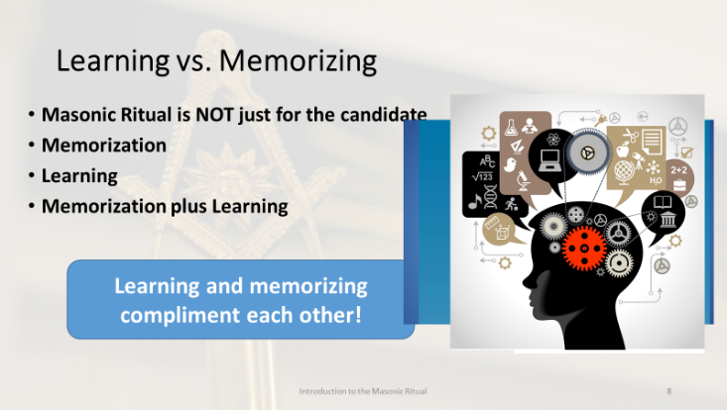
Let’s talk for a minute about the difference between learning and memorizing the ritual and why both are important and necessary.
(CLICK FOR BULLET & PICTURE)
The first thing I want to point out is that Masonic ritual is not just for the candidate. It has other purposes besides conferring the degrees. The ritual is how we communicate our principles and beliefs to a candidate, but if that is the only reason we use it, we are doing it and ourselves a disservice. It also contains details about the Masonic principles as well as instructions for the individual Mason to lead a good and moral life. There is more to learn beyond the ritual, but it should serve as a starting point for every Mason.
(CLICK FOR BULLET & PICTURE)
Memorization is committing the content for the rapid recall and ability to recite things. Memorization is important when it comes to reciting, performing, and teaching the ritual. But it is important to the learning process as well. Memory is used in everything we do. There are many techniques available to increase our ability to memorize things. My recommendation is that you start with the simplest, repetition, and adjust your technique accordingly.
When working on memorizing the ritual, it is important that you memorize the actions and movements along with the words.
(CLICK FOR BULLET & PICTURE)
Learning is the act of comprehending and understanding a topic. Let me explain that there is a difference between understanding the ritual and understanding the deeper lessons and the meaning of Freemasonry. There is a line at the end of the Entered Apprentice degree that I believe communicates Freemasonry’s expectation of the individual Mason to learn and understand the ritual perfectly: “The whole is a regular system of morality, veiled in allegory, which will unfold its beauties to the candid and industrious inquirer.”
(CLICK FOR BULLET & PICTURE)
I cannot stress it enough: memorization of the ritual is crucial to the delivery and execution of it, but memorization alone without seeking to comprehend what has been memorized makes it difficult for the individual Mason to apply the lessons of the Fraternity to his character.

(CLICK FOR TOMBSTONE)
Learning and memorizing the ritual work together to enable the Mason to increase his comprehension of the ritual.

I like to use the example of the Pythagorean Theorem to illustrate this.
(CLICK FOR NEXT SLIDE)

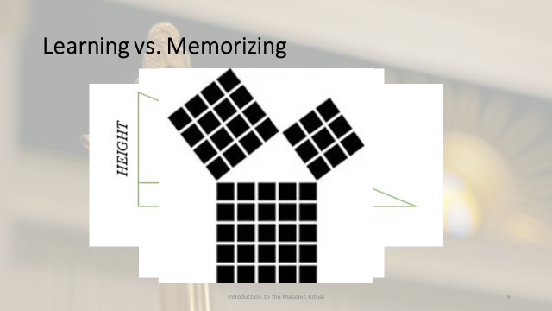

We were all probably taught to memorize this mathematical function at some point: a² + b² = c², or c = the square root of a² + b². However, memorizing the formula did not help us to understand how to use it.

(CLICK)
If we do not learn how to use it, memorizing it does little good. If we are not taught that c represents the hypotenuse,

(CLICK)
or that the hypotenuse is the side opposite the 90-degree angle, and the other particulars, memorizing the formula does not enable us to put it into action.

(CLICK)
Memorizing and learning the ritual works the same way. Memorizing the ritual will enable us to perform it, but learning it enables us to apply it to shaping our character. If we only memorize the meaning of the square and its definitions, we may overlook how to apply it to our lives in dealing with all of mankind to live our lives in a virtuous manner.

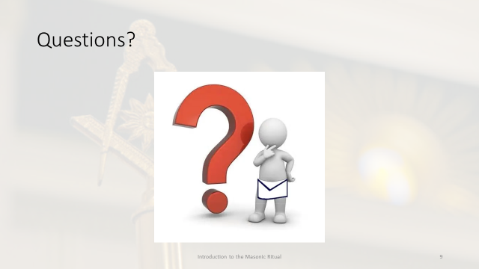
These last few minutes we covered the basics of the Masonic ritual, how it is assembled, how to use it and the individual Mason’s responsibility to it.

Are there any questions? You can send them in through the chat in the meeting or feel free to contact me directly.

