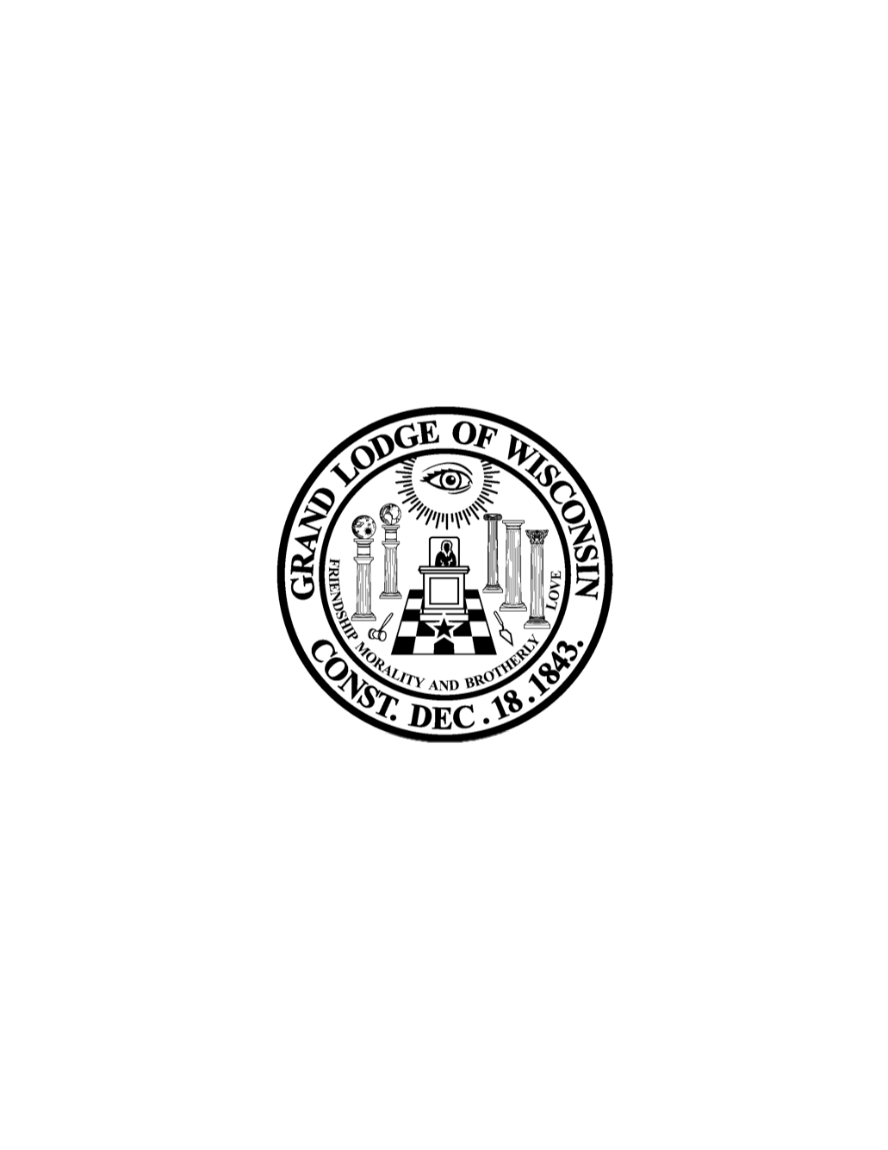

Grand Lodge Free & Accepted Masons of WI

Direct Deposit Agreement Form for GLoW Officers

Authorization Agreement
Name Member ID#

I hereby authorize Grand Lodge Free & Accepted Masons of WI to initiate automatic deposits to my account at the financial institution named below. I also authorize Grand Lodge Free & Accepted Masons of WI to initiate, if necessary, debit entries and adjustments from this account in the event that a credit entry is made in error.
Further, I agree not to hold Grand Lodge Free & Accepted Masons of WI responsible for any delay or loss of funds due to incorrect or incomplete information supplied by me or by my financial institution or due to an error on the part of my financial institution in depositing funds to my account.
This agreement will remain in effect until Grand Lodge Free & Accepted Masons of WI receives a written notice of cancellation from the lodge or financial institution, or until I submit a new direct deposit form to the Grand Lodge.

Account Information
Name of Financial Institution:
Routing Number:
Account Number: |  | ☐ Checking ☐ Savings

Signature
Authorized Signature (Primary): |  | Date:
Authorized Signature (Joint): |  | Date:

Please include a voided check & return this form to the Grand Lodge office Attn Christina
36275 Sunset Dr. Dousman, WI 53118

