May 5, 2016

Brother Robert D. Blask
232 Clark Street, Apt. #1
Pewaukee, WI 53072

Dear Brother Blask:

This is the last of the series of letters I address to each new Brother as he progresses through the Masonic degrees. Again, let me offer you warmest congratulations and welcome you as a Master Mason and member of Wauwatosa Lodge.

It is now timely to consider your future course of action in Masonic affairs. As you have learned, Masonry is a progressive science, and you will find more and more of its inspirational teachings unfolding through the years as you participate in our Lodge activities. Privileged as I am to have served as a Past Grand Master, I find that each new Masonic experience brings a deeper awareness of Freemasonry. It is a continuing, enriching and enlarging philosophy.

First, of course, prepare for your final proficiency examination in the Master Mason Degree. I suggest that you do not delay as the memory work is much easier while the experience of the degree is still fresh in your mind.

Secondly, look at the various avenues for participation in the activities of Wauwatosa Lodge so as to find the areas where you will be the happiest in your new Masonic home. There is such a variety of ways to serve and to benefit: a period of duty on the Stewards’ Committee, waiting on the Brothers who have waited on you; learning to participate as a sideliner in some aspects of the degree work; supporting the Lodge simply by regular attendance at Stated and Special Meetings; calling on a Brother who is ill; bringing wives, families and friends to our social functions; taking up the study of Masonic research; and, of special importance, partaking of all the good fellowship which is available to you through your Lodge.

May you chart your Masonic course with wisdom and humility, and may you experience the rewards which are yours to earn and receive.

Until then, I remain,

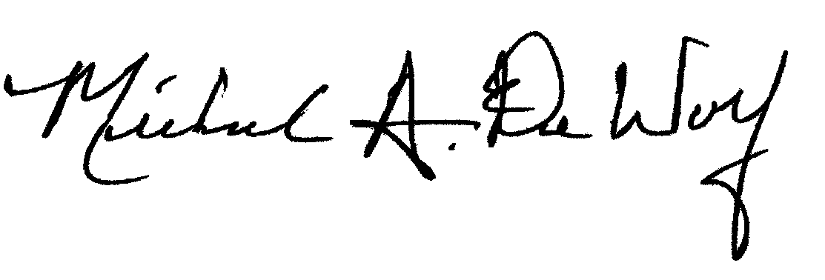
Sincerely and Fraternally,

Michael A. DeWolf, PGM
Secretary/Treasurer
Wauwatosa Lodge No. 267 F&AM

